Azure Data Lake Storage Gen2 (ADLS Gen2)
Azure Data Lake Storage Gen2 is a highly scalable and secure cloud storage service optimized for big data analytics and data lakes. It builds on Azure Blob Storage capabilities but adds file system semantics, hierarchical namespaces, and enhanced performance for analytics workloads.
ADLS Gen2 is designed to store massive volumes of structured, semi-structured, and unstructured data, making it ideal for big data and machine learning scenarios.
Key Features and Use Cases:
- Hierarchical Namespace: Unlike traditional Blob Storage, ADLS Gen2 supports folders and directories, enabling efficient organization and faster file operations at scale.
- Optimized for Analytics: Supports Hadoop Distributed File System (HDFS) and integrates seamlessly with analytics frameworks like Azure Databricks, HDInsight, and Azure Synapse Analytics.
- Supports Multiple Data Types: You can store CSV, JSON, Parquet, Avro, ORC, images, videos, logs, backups, and more.
- Security and Compliance: Provides enterprise-grade security with Azure Active Directory integration, role-based access control (RBAC), and encryption at rest and in transit.
- Cost-effective and Scalable: Automatically scales to handle petabytes of data and millions of files with optimized storage tiers and pricing options.

Common Uses of ADLS Gen2:
- Building data lakes for big data analytics and machine learning.
- Storing large datasets for ETL (Extract, Transform, Load) processes.
- Integrating with analytics tools to perform complex queries and transformations.
- Secure and compliant storage for sensitive data and audit logs.
- Archiving and long-term data retention with tiered storage options.

Create an Azure Data Lake Storage
→ Go to Azure Portal
In the search bar, type “Storage Accounts” or “ADLS Gen2”
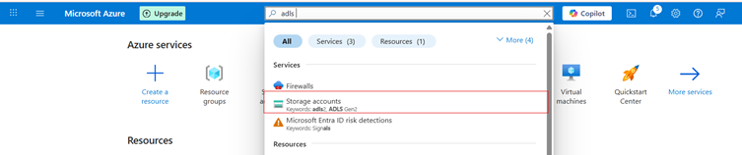

Click on storage accounts and click on create button

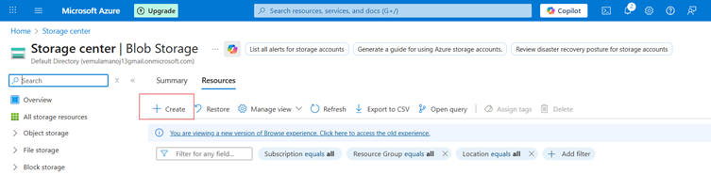

After clicking the Create button, the Basic Details page will appear. Fill in all the required details, and then click the Next button.

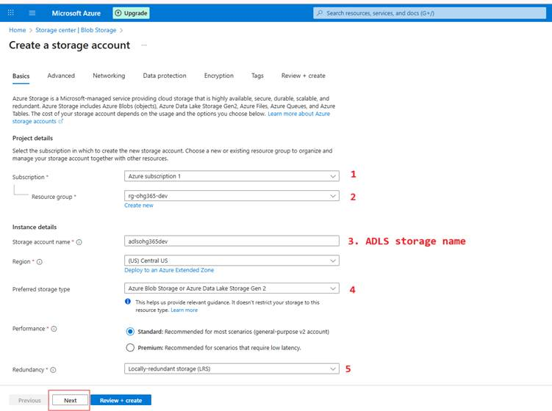

After clicking the Next button, the Advanced field will appear. Select the required checkbox, and then click the Review + Create button.

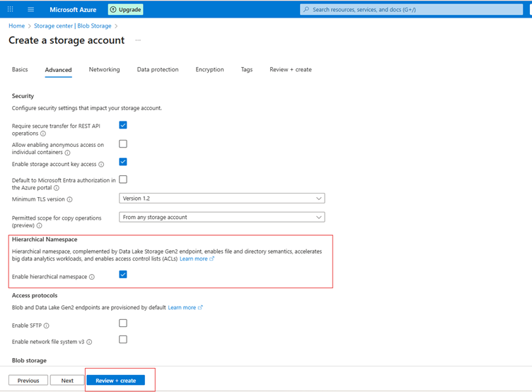

After clicking the Review + Create button, the Basic and Advanced fields will be displayed. Verify all the details, and then click the Create button.

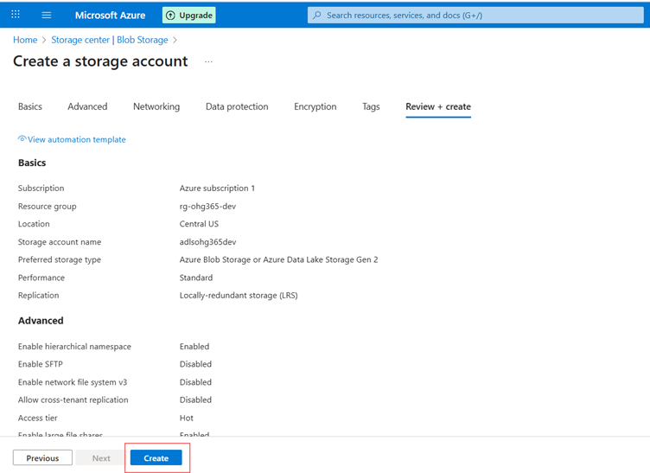

After clicking the Create button, you will be taken to the Overview page. Here, click Go to resource.

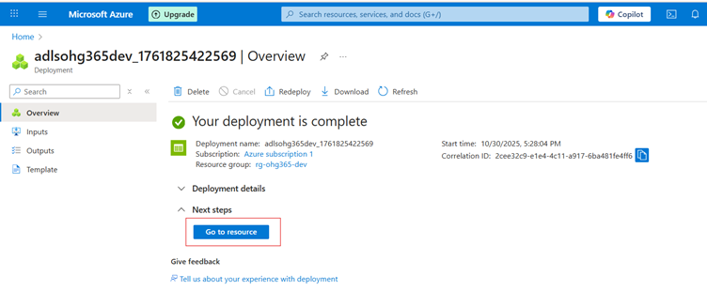

Navigate to Your Resource Group
- In the left-hand menu, click on Resource groups
- Find and click your resource group in your case:
→ rg-ohg365-de

- Check for the Storage Account
- Inside the Overview tab of your resource group, you’ll see a list of all resources.
Look for an item that looks like this:
Type: Storage account
Name: adlsohg365dev (or whatever name you used)
If it appears there, 🎉 congratulations your ADLS Gen2 Storage account has been successfully created

After clicking the Go to resource option, all resource names within the resource group will be displayed in the Overview page.
